**Coventry University**

**220CT Coursework 2021/2022**

Questions: 1,2,4,5,6

Student Name: Chan Yik Kit

Student ID: 56237852

**Question 1 Answer:**

|  |  |
| --- | --- |
| **Mission No.** | **Total Weight** |
| ABC-2237 | 211 kg |
| ABC-3664 | 1.2 kg |
| ABC-2356 | 69 kg |
| ABC-1234 | 3 kg |

Unnormalized Form:

(Mission_no, Country, Mission_date, Agency_no, Lead_agency, {Equipment, quantity, item_weight, total_weight})

First Normal Form:

[1.1] (Mission_no, Country, Mission_date, Agency_no, Lead_agency)

[1.2] (Mission_no, Equipment, quantity, item_weight, total_weight)

Second Normal Form:

[1.1] (Mission_no, Country, Mission_date, Agency_no, Lead_agency)

[1.2.1] (Mission_no, Equipment, quantity, total_weight)

[1.2.2] (Equipment, item_weight)

Third Normal Form:

[1.1.1] (Mission_no, Country, Mission_date, Agency_no)

[1.1.2] (Agency_no, Lead_agency)

[1.2.1] (Mission_no, Equipment, quantity, total_weight)

[1.2.2] (Equipment, item_weight)

Database creation scripts (the whole steps):

|  |
| --- |
| [CREATE](http://localhost:8081/phpmyadmin/url.php?url=https://dev.mysql.com/doc/refman/8.0/en/create-table.html) [DATABASE](http://localhost:8081/phpmyadmin/url.php?url=https://dev.mysql.com/doc/refman/8.0/en/create-table.html) `abc_company`;  [CREATE](http://localhost:8081/phpmyadmin/url.php?url=https://dev.mysql.com/doc/refman/8.0/en/create-table.html) [TABLE](http://localhost:8081/phpmyadmin/url.php?url=https://dev.mysql.com/doc/refman/8.0/en/create-table.html) `abc_company`.`mission` ( `Mission_no` [VARCHAR](http://localhost:8081/phpmyadmin/url.php?url=https://dev.mysql.com/doc/refman/8.0/en/string-types.html)(10) [CHARACTER](http://localhost:8081/phpmyadmin/url.php?url=https://dev.mysql.com/doc/refman/8.0/en/charset.html) [SET](http://localhost:8081/phpmyadmin/url.php?url=https://dev.mysql.com/doc/refman/8.0/en/charset.html) utf8 [COLLATE](http://localhost:8081/phpmyadmin/url.php?url=https://dev.mysql.com/doc/refman/8.0/en/charset-collations.html) utf8_unicode_ci [NOT](http://localhost:8081/phpmyadmin/url.php?url=https://dev.mysql.com/doc/refman/8.0/en/logical-operators.html#operator_not) NULL , `Country` [TEXT](http://localhost:8081/phpmyadmin/url.php?url=https://dev.mysql.com/doc/refman/8.0/en/string-types.html) [CHARACTER](http://localhost:8081/phpmyadmin/url.php?url=https://dev.mysql.com/doc/refman/8.0/en/charset.html) [SET](http://localhost:8081/phpmyadmin/url.php?url=https://dev.mysql.com/doc/refman/8.0/en/charset.html) utf8 [COLLATE](http://localhost:8081/phpmyadmin/url.php?url=https://dev.mysql.com/doc/refman/8.0/en/charset-collations.html) utf8_unicode_ci [NOT](http://localhost:8081/phpmyadmin/url.php?url=https://dev.mysql.com/doc/refman/8.0/en/logical-operators.html#operator_not) NULL , `Mission_date` [DATE](http://localhost:8081/phpmyadmin/url.php?url=https://dev.mysql.com/doc/refman/8.0/en/date-and-time-types.html) [NOT](http://localhost:8081/phpmyadmin/url.php?url=https://dev.mysql.com/doc/refman/8.0/en/logical-operators.html#operator_not) NULL , `Agency_no` [INT](http://localhost:8081/phpmyadmin/url.php?url=https://dev.mysql.com/doc/refman/8.0/en/numeric-types.html)(4) [NOT](http://localhost:8081/phpmyadmin/url.php?url=https://dev.mysql.com/doc/refman/8.0/en/logical-operators.html#operator_not) NULL , PRIMARY KEY (`Mission_no`)) ENGINE = InnoDB;  [CREATE](http://localhost:8081/phpmyadmin/url.php?url=https://dev.mysql.com/doc/refman/8.0/en/create-table.html) [TABLE](http://localhost:8081/phpmyadmin/url.php?url=https://dev.mysql.com/doc/refman/8.0/en/create-table.html) `abc_company`.`agency` ( `Agency_no` [INT](http://localhost:8081/phpmyadmin/url.php?url=https://dev.mysql.com/doc/refman/8.0/en/numeric-types.html)(4) [NOT](http://localhost:8081/phpmyadmin/url.php?url=https://dev.mysql.com/doc/refman/8.0/en/logical-operators.html#operator_not) NULL , `Lead_agency` [VARCHAR](http://localhost:8081/phpmyadmin/url.php?url=https://dev.mysql.com/doc/refman/8.0/en/string-types.html)(20) [CHARACTER](http://localhost:8081/phpmyadmin/url.php?url=https://dev.mysql.com/doc/refman/8.0/en/charset.html) [SET](http://localhost:8081/phpmyadmin/url.php?url=https://dev.mysql.com/doc/refman/8.0/en/charset.html) utf8 [COLLATE](http://localhost:8081/phpmyadmin/url.php?url=https://dev.mysql.com/doc/refman/8.0/en/charset-collations.html) utf8_unicode_ci [NOT](http://localhost:8081/phpmyadmin/url.php?url=https://dev.mysql.com/doc/refman/8.0/en/logical-operators.html#operator_not) NULL , PRIMARY KEY (`Agency_no`)) ENGINE = InnoDB;  [CREATE](http://localhost:8081/phpmyadmin/url.php?url=https://dev.mysql.com/doc/refman/8.0/en/create-table.html) [TABLE](http://localhost:8081/phpmyadmin/url.php?url=https://dev.mysql.com/doc/refman/8.0/en/create-table.html) `abc_company`.`total_weight` ( `Mission_no` [VARCHAR](http://localhost:8081/phpmyadmin/url.php?url=https://dev.mysql.com/doc/refman/8.0/en/string-types.html)(10) [CHARACTER](http://localhost:8081/phpmyadmin/url.php?url=https://dev.mysql.com/doc/refman/8.0/en/charset.html) [SET](http://localhost:8081/phpmyadmin/url.php?url=https://dev.mysql.com/doc/refman/8.0/en/charset.html) utf8 [COLLATE](http://localhost:8081/phpmyadmin/url.php?url=https://dev.mysql.com/doc/refman/8.0/en/charset-collations.html) utf8_unicode_ci [NOT](http://localhost:8081/phpmyadmin/url.php?url=https://dev.mysql.com/doc/refman/8.0/en/logical-operators.html#operator_not) NULL , `Equipment` [VARCHAR](http://localhost:8081/phpmyadmin/url.php?url=https://dev.mysql.com/doc/refman/8.0/en/string-types.html)(50) [CHARACTER](http://localhost:8081/phpmyadmin/url.php?url=https://dev.mysql.com/doc/refman/8.0/en/charset.html) [SET](http://localhost:8081/phpmyadmin/url.php?url=https://dev.mysql.com/doc/refman/8.0/en/charset.html) utf8 [COLLATE](http://localhost:8081/phpmyadmin/url.php?url=https://dev.mysql.com/doc/refman/8.0/en/charset-collations.html) utf8_unicode_ci [NOT](http://localhost:8081/phpmyadmin/url.php?url=https://dev.mysql.com/doc/refman/8.0/en/logical-operators.html#operator_not) NULL , `total_weight` [VARCHAR](http://localhost:8081/phpmyadmin/url.php?url=https://dev.mysql.com/doc/refman/8.0/en/string-types.html)(10) [CHARACTER](http://localhost:8081/phpmyadmin/url.php?url=https://dev.mysql.com/doc/refman/8.0/en/charset.html) [SET](http://localhost:8081/phpmyadmin/url.php?url=https://dev.mysql.com/doc/refman/8.0/en/charset.html) utf8 [COLLATE](http://localhost:8081/phpmyadmin/url.php?url=https://dev.mysql.com/doc/refman/8.0/en/charset-collations.html) utf8_unicode_ci [NOT](http://localhost:8081/phpmyadmin/url.php?url=https://dev.mysql.com/doc/refman/8.0/en/logical-operators.html#operator_not) NULL , PRIMARY KEY (`Equipment`)) ENGINE = InnoDB;  [CREATE](http://localhost:8081/phpmyadmin/url.php?url=https://dev.mysql.com/doc/refman/8.0/en/create-table.html) [TABLE](http://localhost:8081/phpmyadmin/url.php?url=https://dev.mysql.com/doc/refman/8.0/en/create-table.html) `abc_company`.`equipment` ( `Equipment` [VARCHAR](http://localhost:8081/phpmyadmin/url.php?url=https://dev.mysql.com/doc/refman/8.0/en/string-types.html)(50) [CHARACTER](http://localhost:8081/phpmyadmin/url.php?url=https://dev.mysql.com/doc/refman/8.0/en/charset.html) [SET](http://localhost:8081/phpmyadmin/url.php?url=https://dev.mysql.com/doc/refman/8.0/en/charset.html) utf8 [COLLATE](http://localhost:8081/phpmyadmin/url.php?url=https://dev.mysql.com/doc/refman/8.0/en/charset-collations.html) utf8_unicode_ci [NOT](http://localhost:8081/phpmyadmin/url.php?url=https://dev.mysql.com/doc/refman/8.0/en/logical-operators.html#operator_not) NULL , `quantity` [INT](http://localhost:8081/phpmyadmin/url.php?url=https://dev.mysql.com/doc/refman/8.0/en/numeric-types.html)(10) [NOT](http://localhost:8081/phpmyadmin/url.php?url=https://dev.mysql.com/doc/refman/8.0/en/logical-operators.html#operator_not) NULL , `item_weight` [VARCHAR](http://localhost:8081/phpmyadmin/url.php?url=https://dev.mysql.com/doc/refman/8.0/en/string-types.html)(10) [CHARACTER](http://localhost:8081/phpmyadmin/url.php?url=https://dev.mysql.com/doc/refman/8.0/en/charset.html) [SET](http://localhost:8081/phpmyadmin/url.php?url=https://dev.mysql.com/doc/refman/8.0/en/charset.html) utf8 [COLLATE](http://localhost:8081/phpmyadmin/url.php?url=https://dev.mysql.com/doc/refman/8.0/en/charset-collations.html) utf8_unicode_ci [NOT](http://localhost:8081/phpmyadmin/url.php?url=https://dev.mysql.com/doc/refman/8.0/en/logical-operators.html#operator_not) NULL , PRIMARY KEY (`Equipment`)) ENGINE = InnoDB;  [ALTER](http://localhost:8081/phpmyadmin/url.php?url=https://dev.mysql.com/doc/refman/8.0/en/alter-table.html) [TABLE](http://localhost:8081/phpmyadmin/url.php?url=https://dev.mysql.com/doc/refman/8.0/en/alter-table.html) `equipment` ADD `Equipment` [VARCHAR](http://localhost:8081/phpmyadmin/url.php?url=https://dev.mysql.com/doc/refman/8.0/en/string-types.html)(50) [NOT](http://localhost:8081/phpmyadmin/url.php?url=https://dev.mysql.com/doc/refman/8.0/en/logical-operators.html#operator_not) NULL FIRST;  [ALTER](http://localhost:8081/phpmyadmin/url.php?url=https://dev.mysql.com/doc/refman/8.0/en/alter-table.html) [TABLE](http://localhost:8081/phpmyadmin/url.php?url=https://dev.mysql.com/doc/refman/8.0/en/alter-table.html) `mission` ADD UNIQUE(`Agency_no`);  ALTER TABLE `total_weight` ADD UNIQUE(`Mission_no`);  ALTER TABLE `equipment` ADD UNIQUE(`Equipment`);  ALTER TABLE `equipment` ADD PRIMARY KEY(`item_weight`);  [ALTER](http://localhost:8081/phpmyadmin/url.php?url=https://dev.mysql.com/doc/refman/8.0/en/alter-table.html) [TABLE](http://localhost:8081/phpmyadmin/url.php?url=https://dev.mysql.com/doc/refman/8.0/en/alter-table.html) `total_weight` ADD INDEX(`Equipment`);  [ALTER](http://localhost:8081/phpmyadmin/url.php?url=https://dev.mysql.com/doc/refman/8.0/en/alter-table.html) [TABLE](http://localhost:8081/phpmyadmin/url.php?url=https://dev.mysql.com/doc/refman/8.0/en/alter-table.html) `mission` ADD FOREIGN KEY (`Mission_no`) REFERENCES `total_weight`(`Mission_no`);  [ALTER](http://localhost:8081/phpmyadmin/url.php?url=https://dev.mysql.com/doc/refman/8.0/en/alter-table.html) [TABLE](http://localhost:8081/phpmyadmin/url.php?url=https://dev.mysql.com/doc/refman/8.0/en/alter-table.html) `agency` ADD FOREIGN KEY (`Agency_no`) REFERENCES `mission` (`Agency_no`);  [ALTER](http://localhost:8081/phpmyadmin/url.php?url=https://dev.mysql.com/doc/refman/8.0/en/alter-table.html) [TABLE](http://localhost:8081/phpmyadmin/url.php?url=https://dev.mysql.com/doc/refman/8.0/en/alter-table.html) `total_weight` ADD FOREIGN KEY (`Equipment`)REFERENCES `equipment` (`Equipment`);  ALTER TABLE `equipment` DROP `quantity`;  [ALTER](http://localhost:8081/phpmyadmin/url.php?url=https://dev.mysql.com/doc/refman/8.0/en/alter-table.html) [TABLE](http://localhost:8081/phpmyadmin/url.php?url=https://dev.mysql.com/doc/refman/8.0/en/alter-table.html) `total_weight` ADD `quantity` [INT](http://localhost:8081/phpmyadmin/url.php?url=https://dev.mysql.com/doc/refman/8.0/en/numeric-types.html)(10) [NOT](http://localhost:8081/phpmyadmin/url.php?url=https://dev.mysql.com/doc/refman/8.0/en/logical-operators.html#operator_not) NULL AFTER `Equipment`;  [ALTER](http://localhost:8081/phpmyadmin/url.php?url=https://dev.mysql.com/doc/refman/8.0/en/alter-table.html) [TABLE](http://localhost:8081/phpmyadmin/url.php?url=https://dev.mysql.com/doc/refman/8.0/en/alter-table.html) mission AUTO_INCREMENT=100;  [ALTER](http://localhost:8081/phpmyadmin/url.php?url=https://dev.mysql.com/doc/refman/8.0/en/alter-table.html) [TABLE](http://localhost:8081/phpmyadmin/url.php?url=https://dev.mysql.com/doc/refman/8.0/en/alter-table.html) `mission` CHANGE `Mission_no` `Mission_no` [INT](http://localhost:8081/phpmyadmin/url.php?url=https://dev.mysql.com/doc/refman/8.0/en/numeric-types.html)(10) NULL AUTO_INCREMENT;  [ALTER](http://localhost:8081/phpmyadmin/url.php?url=https://dev.mysql.com/doc/refman/8.0/en/alter-table.html) [TABLE](http://localhost:8081/phpmyadmin/url.php?url=https://dev.mysql.com/doc/refman/8.0/en/alter-table.html) `total_weight` [DROP](http://localhost:8081/phpmyadmin/url.php?url=https://dev.mysql.com/doc/refman/8.0/en/drop-index.html) [INDEX](http://localhost:8081/phpmyadmin/url.php?url=https://dev.mysql.com/doc/refman/8.0/en/drop-index.html) `Mission_no`;  ALTER TABLE `mission` DROP `Mission_no`;  [ALTER](http://localhost:8081/phpmyadmin/url.php?url=https://dev.mysql.com/doc/refman/8.0/en/alter-table.html) [TABLE](http://localhost:8081/phpmyadmin/url.php?url=https://dev.mysql.com/doc/refman/8.0/en/alter-table.html) `mission` ADD `Mission_no` [INT](http://localhost:8081/phpmyadmin/url.php?url=https://dev.mysql.com/doc/refman/8.0/en/numeric-types.html)(10) NULL AUTO_INCREMENT AFTER `Country`, ADD PRIMARY KEY (`Mission_no`);  ALTER TABLE `total_weight` DROP `Mission_no`;  [ALTER](http://localhost:8081/phpmyadmin/url.php?url=https://dev.mysql.com/doc/refman/8.0/en/alter-table.html) [TABLE](http://localhost:8081/phpmyadmin/url.php?url=https://dev.mysql.com/doc/refman/8.0/en/alter-table.html) `total_weight` ADD `Mission_no` [INT](http://localhost:8081/phpmyadmin/url.php?url=https://dev.mysql.com/doc/refman/8.0/en/numeric-types.html)(10) NULL AUTO_INCREMENT FIRST, ADD UNIQUE (`Mission_no`);  [UPDATE](http://localhost:8081/phpmyadmin/url.php?url=https://dev.mysql.com/doc/refman/8.0/en/update.html) `mission` [SET](http://localhost:8081/phpmyadmin/url.php?url=https://dev.mysql.com/doc/refman/8.0/en/set.html) `Mission_no` = '3664' WHERE `mission`.`Mission_no` = 4;  [UPDATE](http://localhost:8081/phpmyadmin/url.php?url=https://dev.mysql.com/doc/refman/8.0/en/update.html) `mission` [SET](http://localhost:8081/phpmyadmin/url.php?url=https://dev.mysql.com/doc/refman/8.0/en/set.html) `Mission_no` = '2237' WHERE `mission`.`Mission_no` = 3;  [UPDATE](http://localhost:8081/phpmyadmin/url.php?url=https://dev.mysql.com/doc/refman/8.0/en/update.html) `mission` [SET](http://localhost:8081/phpmyadmin/url.php?url=https://dev.mysql.com/doc/refman/8.0/en/set.html) `Mission_no` = '2356' WHERE `mission`.`Mission_no` = 2;  ALTER TABLE `total_weight` DROP `quantity`;  ALTER TABLE `total_weight` DROP INDEX `Equipment`;  [ALTER](http://localhost:8081/phpmyadmin/url.php?url=https://dev.mysql.com/doc/refman/8.0/en/alter-table.html) [TABLE](http://localhost:8081/phpmyadmin/url.php?url=https://dev.mysql.com/doc/refman/8.0/en/alter-table.html) `equipment` ADD `quantity` [INT](http://localhost:8081/phpmyadmin/url.php?url=https://dev.mysql.com/doc/refman/8.0/en/numeric-types.html)(10) [NOT](http://localhost:8081/phpmyadmin/url.php?url=https://dev.mysql.com/doc/refman/8.0/en/logical-operators.html#operator_not) NULL AFTER `Equipment`;  ALTER TABLE `total_weight` DROP `Equipment`;  ALTER TABLE `total_weight` ADD UNIQUE(`total_weight`);  [ALTER](http://localhost:8081/phpmyadmin/url.php?url=https://dev.mysql.com/doc/refman/8.0/en/alter-table.html) [TABLE](http://localhost:8081/phpmyadmin/url.php?url=https://dev.mysql.com/doc/refman/8.0/en/alter-table.html) `equipment` ADD `total_weight` [VARCHAR](http://localhost:8081/phpmyadmin/url.php?url=https://dev.mysql.com/doc/refman/8.0/en/string-types.html)(10) [CHARACTER](http://localhost:8081/phpmyadmin/url.php?url=https://dev.mysql.com/doc/refman/8.0/en/charset.html) [SET](http://localhost:8081/phpmyadmin/url.php?url=https://dev.mysql.com/doc/refman/8.0/en/charset.html) utf8 [COLLATE](http://localhost:8081/phpmyadmin/url.php?url=https://dev.mysql.com/doc/refman/8.0/en/charset-collations.html) utf8_unicode_ci [NOT](http://localhost:8081/phpmyadmin/url.php?url=https://dev.mysql.com/doc/refman/8.0/en/logical-operators.html#operator_not) NULL FIRST;  [ALTER](http://localhost:8081/phpmyadmin/url.php?url=https://dev.mysql.com/doc/refman/8.0/en/alter-table.html) [TABLE](http://localhost:8081/phpmyadmin/url.php?url=https://dev.mysql.com/doc/refman/8.0/en/alter-table.html) `equipment` DROP PRIMARY KEY;  ALTER TABLE `equipment` DROP `total_weight`;  ALTER TABLE `equipment` DROP `quantity`;  ALTER TABLE `total_weight` DROP INDEX `total_weight`;  ALTER TABLE `total_weight` ADD `quantity` INT(10) NOT NULL AFTER `total_weight`; |

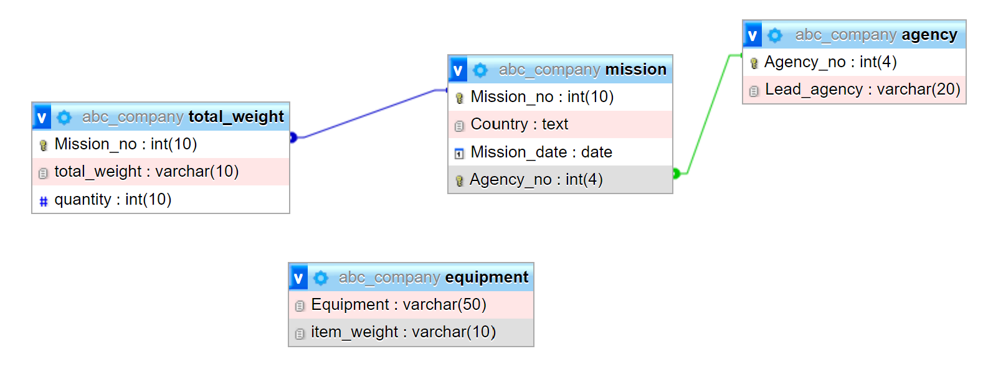Data insertion / preparation scripts:

Database ‘Agency’:

|  |
| --- |
| [INSERT](http://localhost:8081/phpmyadmin/url.php?url=https://dev.mysql.com/doc/refman/8.0/en/insert.html) INTO `agency` (`Agency_no`, `Lead_agency`) [VALUES](http://localhost:8081/phpmyadmin/url.php?url=https://dev.mysql.com/doc/refman/8.0/en/miscellaneous-functions.html#function_values) ('178', 'JAXA'),   ('526', 'ESA'), ('167', 'NASA'), ('032', 'Roskosmos') |
| [SELECT](http://localhost:8081/phpmyadmin/url.php?url=https://dev.mysql.com/doc/refman/8.0/en/select.html) * FROM `agency`; |

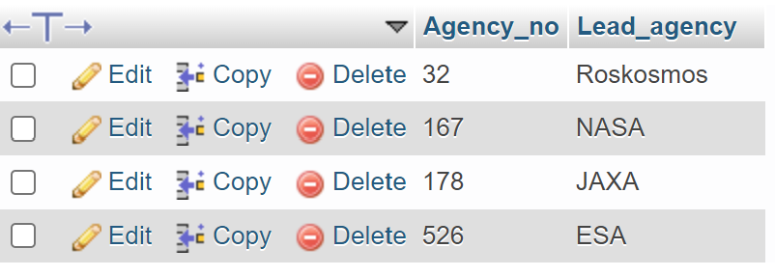

Database ‘equipment’:

|  |
| --- |
| [INSERT](http://localhost:8081/phpmyadmin/url.php?url=https://dev.mysql.com/doc/refman/8.0/en/insert.html) INTO `equipment` (`Equipment`, `item_weight`) [VALUES](http://localhost:8081/phpmyadmin/url.php?url=https://dev.mysql.com/doc/refman/8.0/en/miscellaneous-functions.html#function_values) ('Potable water dispenser', '100 kg'), ('Flexible air duct', '0.5 kg'), ('Small storage Rack', '2 kg'), ('Bio filter', '0.20 kg'), ('Battery pack', '5 kg'), ('Urine transfer tubing', '1.5 kg'), ('O2 scrubber', '50 kg'); |
| [SELECT](http://localhost:8081/phpmyadmin/url.php?url=https://dev.mysql.com/doc/refman/8.0/en/select.html) * FROM `equipment`; |

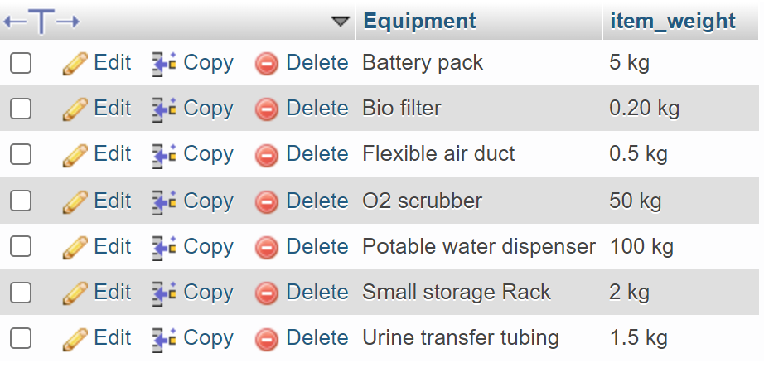

Database ‘mission’:

|  |
| --- |
| [INSERT](http://localhost:8081/phpmyadmin/url.php?url=https://dev.mysql.com/doc/refman/8.0/en/insert.html) INTO `mission` (`Mission_no`, `Country`, `Mission_date`, `Agency_no`) [VALUES](http://localhost:8081/phpmyadmin/url.php?url=https://dev.mysql.com/doc/refman/8.0/en/miscellaneous-functions.html#function_values) ('2237', 'Japan', '2013-12-14', '178'), ('3664', 'EU', '2014-01-16', '526'), ('2356', 'USA', '2014-02-12', '167'), ('1234', 'Russia', '2014-04-16', '32') |
| [SELECT](http://localhost:8081/phpmyadmin/url.php?url=https://dev.mysql.com/doc/refman/8.0/en/select.html) * FROM `mission`; |

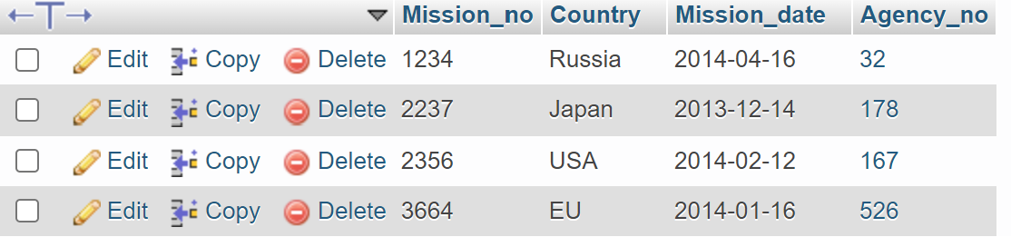

Database ‘total_weight’:

|  |
| --- |
| [INSERT](http://localhost:8081/phpmyadmin/url.php?url=https://dev.mysql.com/doc/refman/8.0/en/insert.html) INTO `total_weight` (`Mission_no`, `total_weight`, `quantity`) [VALUES](http://localhost:8081/phpmyadmin/url.php?url=https://dev.mysql.com/doc/refman/8.0/en/miscellaneous-functions.html#function_values) ('2237', '211 kg', '12'), ('3664', '1.2 kg', '6'), ('2356', '69 kg', '8'), ('1234', '3 kg', '3'); |
| [SELECT](http://localhost:8081/phpmyadmin/url.php?url=https://dev.mysql.com/doc/refman/8.0/en/select.html) * FROM `equipment`; |

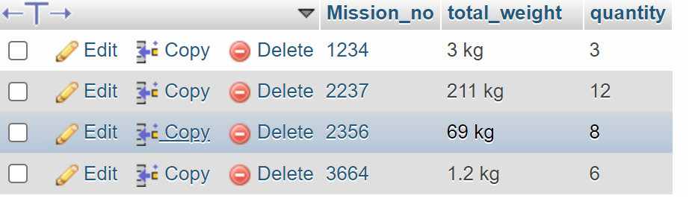

Question 2 Answer:

A)

Because of the convenience, simplicity, and security of the Rational database, a specific table may be made to be confidential and accessible by multi-users at the same time. A small business rational database, for example, maybe used by more than one employee at the same time, and it can be accessed by employees who do not have a high level of technological understanding. Information retrieval (IR) systems are relatively easy to explain, many different features can be incorporated, and efficient processing because many documents can be eliminated from the search. Relational databases can store data accurately by using primary keys and foreign keys to make the tables interrelated to each other, ensuring that the data does not duplicate, while IR system results only predict, which is not always accurate.

Furthermore, certain NoSQL databases do not require schemas to begin working with data for dynamic schemas. Relational Database is more complex because the schema defined must be changed whenever the requirements change every time.

Moreover, in comparison to NoSQL databases, relational databases require the installation of costly storage systems and proprietary servers, whereas NoSQL databases are designed for use with low-cost commodity hardware and can be easily installed in low-cost commodity hardware clusters as transaction and data volumes grow which means like a small business can process and store a lot more data for a lot less money. Plus, NoSQL databases are very new in comparison to Relational Databases; they lack the dependability features that Relational Databases provide since NoSQL is incompatible with SQL. Developers will have to write their code to support ACID, making their systems more complicated. For example, this may lower the number of security programs that commit transactions in bank systems, making them less reliable and with fewer features. At the same time, the downsides of IR systems include the fact that their success is dependent on the user, that simple searches seldom work, and that sophisticated inquiries are difficult which is not apply for a bank system.

B)

Data is a collection of unprocessed, basic, and unedited numbers and facts. In contrast to data, information gives context and insights based on the data acquired. Data does not rely on information and information does not rely on data. Data does not deliver into details. After arranging the data, information is derived via conclusions with correlation. Information exists to bring insights and meaning, whereas data has no true purpose. Data are facts or recordings of occurrences or transactions that are distinct and objective. Data are facts or recordings of occurrences or transactions that are distinct and objective. The information can convey and communicate, as well as influence judgments and actions.

Every business relies on the data created, from data to information and information to business intelligence. Businesses are making use of this technique to differentiate themselves in the market. For example, data and information from market research such as customer experience questionnaires and industry analyses are used in the retail business. Analysts isolate goods data from a linear stream of data to construct a business plan that meets the demands of various entities within a company. Through analytical information and expertise, the store may learn about its target market's trends and generate more money in OLTP.

Question 4 Answer:

Build an e-commerce website and set up YouTube, Facebook, and Instagram promotion pages for social media marketing, which can reduce marketing spend while increasing lead generation by providing metrics that provide companies with additional marketplace insight and encourage conversions. Social media marketing focuses on providing people with the material they find important and wish to share throughout their social networks, resulting in improved exposure and website traffic, thanks to big data and media search engine diversity. Shares of material, videos, and photos on social media affect SEO efforts, tracking cookies and cross-sharing by increasing relevancy in search results on social media networks like Facebook, YouTube, and Instagram, as well as search engines like Google and Yahoo (Monnappa, 2021). **The greater the number of uploads and clicks and relevance, the greater the exposure, and the more customers will attract.**

First, we require consumer feedback in the form of surveys. The data from consumer retail data, such as charts in market search and profit and loss accounting reports, comes next. When users use our website, we can collect their IP addresses and online action data utilizing WIFI. We can recommend and present the consumer with appropriate items based on the above information by keeping search records. By using a WIFI connection and offline reporting, we acquire data from our consumers. Utilizing the clustering and association machine learning technology to analyse the raw gathered data from research and categorize each data point into a specific group to know the related traits and features. For example, 65 percent of customers like shopping between 10 p.m. to 2 a.m. Then, to attract additional buyers, publish the appropriate items on social networking platforms. We may evaluate the grouping and information from acquired data, using charts created from a database and analysis tool. For example, instead of snacks, customers generally brought cosmetic items from our website, and cosmetic sales are increasing faster than snacks. This allows us to understand the business's strengths and move a portion of the cost from snacks to cosmetics items, lowering earnings and increasing consumer satisfaction.

Social media marketing like Facebook, YouTube, and Google, etc are recommendation Engines for tracking cookies and tag Suggestions. These search engines can be analysing the likes, records and predict customer behaviours which for analysis to decide business strategy for a business. The diversity and characteristics of big data broaden and virtualize the business, allowing it to be used not just on-site but also online. By using big data analysis, you may better manage customer connections, attract future consumers, and develop new goods and services. You can also improve your company strategy by discovering a new trend that could help you better comprehend some scientific or technical fields. Building an eCommerce website and setting up YouTube, Facebook, and Instagram marketing pages, in my opinion, is an essential step in starting a successful retail business.

Reference List

Frank, S., 2019. How to Understand Common Patterns in Big Data: The Case of Human Collective Memory. SSRN Electronic Journal.

Monnappa, A., 2021. How Facebook is Using Big Data: The Good, the Bad, and the Ugly. [online] Simplilearn. Available at: <https://www.simplilearn.com/how-facebook-is-using-big-data-article> [Accessed 12 November 2021].

Question 5 Answer:

a)

The key difference between machine learning and deep learning is their learning methods and ability. Deep learning is comparable to machine learning in terms of functions and capabilities, but it has distinct characteristics. Deep learning is a subset of machine learning, which comprises algorithms that read data, learn from it, and then use what they've learned to make intelligent judgments. Deep learning is an extension of machine learning that employs a programmable neural network to enable machines to make accurate judgments without the assistance of humans since they have the capacity to self-learn.

b)

Unsupervised learning, as opposed to supervised machine learning, employs machine learning algorithms to evaluate and cluster unlabelled datasets and can be used to identify the underlying structure of the data. Without the need for human interaction, these algorithms uncover hidden patterns or data groupings. It is the best option for exploratory data analysis, cross-selling techniques, consumer segmentation, and picture identification because of its capacity to detect similarities and contrasts in information. For example, under the clustering model, customer segmentation, or identifying distinct client groups around which marketing or other company strategies might be built. Anomaly detection is also used by Intrusion Detection Systems (IDS). In addition, merchants frequently employ Association mining for basket analysis since it lets analysts uncover commodities that are frequently purchased together and design more successful marketing and merchandising strategies.

c)

In the field of elderly care, artificial intelligence is increasingly being developed specifically to care for the elderly. Thanks to the AI robots' machine learning capabilities, they can converse with the elderly, check their health status, and complete simple daily tasks in the elderly centre, thereby alleviating labour shortages and improving the elderly's quality of life. Furthermore, some AI robots have learned to assess human health and provide appropriate medication recommendations, reducing doctor strain and the chance of misunderstandings as well as the risk of developing additional diseases. AI monitoring algorithms that continuously examine input data may be able to notice that an older individual is taking a longer and longer time to rise or restore equilibrium, something a human could miss. In these cases, machine learning will aid in the expansion of their dataset, allowing them to deliver better service in the future.

d)

Autonomous cars have the potential to reduce human errors and prevent millions of fatalities that might otherwise occur. One of the most serious concerns with autonomous driving is that objects are identified incorrectly. The systems can increase perception and recognize things with more accuracy with upgraded and more extended machine learning models. Training the system improves data validation and ensures that the data its learning is typical of genuine distribution in the real world. This avoids a large reliance on a single parameter or a crucial collection of details, which may otherwise lead to a system reaching an incorrect conclusion. One of the advantages of using machine learning for object detection and classification is this. Furthermore, because 5G is quicker than 4G, the picture, car cameras, and mapping tractions are more precise and clearer, reducing the risk of accidents and providing a better driving experience. Furthermore, the machine learning model and 5G connection approach can identify and assess a safe driving environment for the driver, such as the temperature of the air conditioning inside the car and the detection of the driver's state to avoid any accidents.

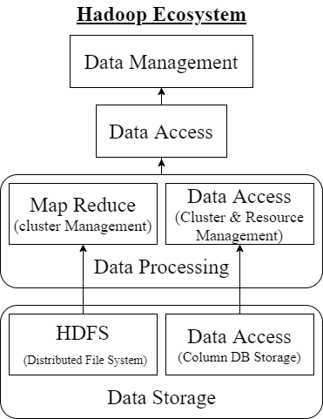Question 6 Answer:

a)

Hadoop is an open-source ecosystem of components that offers a range of services to address big data concerns and radically alters how organizations store, process, and analyse data. Hadoop allows many types of analytic workloads to run concurrently on the same data on industry-standard hardware at a massive scale compared with the traditional system. Hadoop is utilized for both research and production by a wide spectrum of industries and organizations, and it is made up of Apache projects as well as commercial tools and solutions. Hadoop is a framework that consists of a number of modules that are supported by a variety of technologies. HDFS, MapReduce, YARN, and Hadoop Common are the four core components of Hadoop. The majority of the tools or solutions are utilized to complement or support these key components. All of these instruments operate together to offer data absorption, analysis, storage, and maintenance, among other functions.

Hadoop Distributed File System (HDFS) is the fundamental component of the Hadoop ecosystem, and it is responsible for storing enormous data sets of structured or unstructured data across several nodes while also keeping the information in the form of log files. The name node and data node are the two main components of HDFS. HDFS is a distributed file system that can manage large data sets and operates on commodity hardware. It's used to scale an Apache Hadoop cluster from a few to hundreds of nodes. HDFS maintains all coordination between clusters and hardware, therefore it is at the centre of the system.

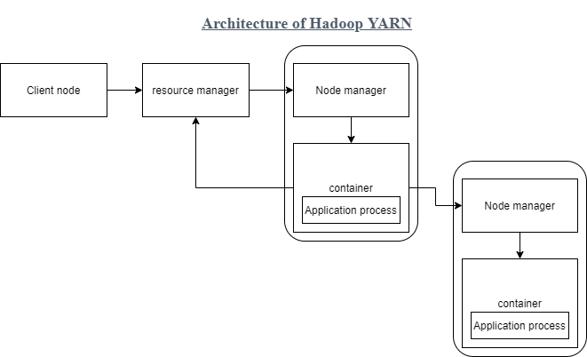

Yet Another Resource Negotiator (YARN) is a Hadoop System component that helps manage resources across clusters and conducts scheduling and resource allocation. It is made up of four major components: resource manager, nodes manager, application manager, and resource manager. The resource manager is in charge of allocating resources for applications in a system, whereas node managers are in charge of allocating resources such as CPU, memory, and bandwidth per machine, and then acknowledge the resource manager. The application manager serves as an interface between the resource management and the node manager, negotiating on their behalf.

MapReduce is a software framework and programming paradigm for processing huge volumes of data that may be described as programming-based data processing. MapReduce allows for the transfer of processing logic and assists in the creation of applications that turn big data sets into manageable ones by leveraging distributed and parallel algorithms. Furthermore, every programmer is required to define two functions: map (map( )) and reduce (reduce( )). In Map jobs, data is separated and mapped, whereas in Reduce jobs, data is jumbled and reduced. Hadoop can run MapReduce applications written in a number of different programming languages, including Java, Python and C++ language. The concurrent nature of MapReduce algorithms in cloud computing makes them perfect for large-scale data analysis across several servers in a cluster.

Lastly, Hadoop Common refers to additional common utilities and libraries that support other Hadoop modules and is an important element or module of the Apache Hadoop Framework.

Netflix is committed to open source and has spent years building and hosting on Amazon’s AWS cloud and having good resources management. Netflix makes use of and contributes to open-source technologies to deliver the best Internet television network. Netflix's deployment technology enables us to design and integrate new features into our global deployments, which serve subscribers in more than 50 countries. Their emphasis on dependability set the standard for cloud-based elastic deployments with many failover levels. They deliver data technology that supports their subscribers in real-time using big data analytics. It has a thriving ecosystem of big data technologies that aid in the development of its algorithms and analytics. They utilize and contribute to open-source technologies that are widely used, such as Hadoop. In addition, Netflix created and provided various new tools and services to its data platform, which have further elevated its data platform. Netflix makes the most of big data tools and services by storing code and data on the cloud, allowing them to provide actionable insight at a large scale in terms of setup their infrastructure.

b)

A blockchain is a decentralized database that is shared across computer network nodes. A blockchain acts as a database, storing information in a digital format. Blockchains are best recognized for preserving a secure and decentralized record of transactions in cryptocurrency systems. A cryptocurrency, such as bitcoin, is a digital or virtual currency protected by cryptography, making it almost difficult to counterfeit or double-spend. Cryptocurrencies are a type of digital asset based on a network that is dispersed over a large number of computers that allows them to operate beyond the jurisdiction of governments and central authorities. They are typically not issued by any central authority. Nonfungible tokens, or NFTs, are one-of-a-kind assets that can't be replaced, and they're validated and stored using blockchain technology. They may include everything from music to a website address, but digital artwork is the current fad.

In applications of e-Commerce, blockchain is secure but third parties are difficult to follow if something goes wrong, which is not suited for every firm. When making a payment, the nature of cryptocurrency prevents counterfeiting and double-spending, allowing companies to conduct more accurate transactions, but it also poses a significant risk because it is not under the authority of the government or other authorities. At the same time, when purchasing artwork online, NFT provides a more virtualized shopping experience, but it is priced based on the artist's reputation, which poses a high risk of becoming a bubble market due to its insecure price transactions and inability to gain customer confidence which is hard to expand the NFT market.

c)

Facebook and Line in social media, Google in search, Taobao in eCommerce, and others such as Weibo Login, online payment in Line, and YouTube data are some of the most popular examples of application programming interface (API) in social media. The graphics API is the primary technique for writing and retrieving data on the Facebook and Line open platforms in situations like Facebook and Line. It's an HTTP-based API that lets apps query data, publishes new trends, manage adverts, add photographs, and do a variety of other things. The user sends the data to the API, which then processes it logically and returns the response to the user via the API. API stands for an application programming interface.